Supervisor: Prof. Dr.-Ing. Bernd Hellingrath

Tutor: Philipp Saalmann, MSc IS

Presented by: Ben Matheja  
Theißingstraße 5  
48153 Münster  
ben.matheja@uni-muenster.de

Date of Submission: 2016-02-28

Title:

Usability of Information Systems Employing Decentralized Planning Methods

Seminar Thesis

In the context of the seminar “Concepts of Decentralized Planning Methods for Cyber-Physical Systems”

at the Chair for Information Systems and Information Management

Content

Figures III

1 Introduction 1

2 Foundations 2

2.1 Industrie 4.0 2

2.2 Cyber-Physical Systems 3

2.3 Usability of information systems 5

2.4 Planning-tasks of the Supply Chain 6

2.5 Production Planning and control 8

3 Impact of Industrie 4.0 innovations on PPC 12

3.1 Production Program and Material Requirements Planning 12

3.2 In-house Production Planning and Control 12

3.3 Human 13

4 Concept of Integration 14

4.1 Application / Processes 14

4.2 Humans 14

References 15

# Figures

Figure 1 Hellingrath Task model for IT-systems of SCM 7

Figure 2 Task model for Production planning and control based on (Schuh and Gierth 2006) 9

**Tables**

Table 1 Tasks of Process and Production Planning adapted from (Lachenmaier et al. 2015) 12

# Introduction

The following thesis is structured as follows.

In the first part, the reader is presented with an introduction into the research topic and a motivation for the need of research in this area. The outcome of this section shall be an idea, why it is necessary that one should perform further investigation. The second part contains presents the research method used in this thesis. As the thesis concludes with an evaluation result of available software packages regarding the degree of matching the facilitated requirements it is necessary to follow a formal method.

The third part shall lay the foundations and provides the reader with a short roundup of the key concepts used in the seminar thesis.

The fourth part presents requirements an information system has to satisfy in order to implement decentralized planning approaches. This part will exclusively focus on the requirements stemming onto applications, processes, organizational structures and the human in between of these.

The fifth part shortly presents the results of the market research, then transforms the obtained requirements into evaluation criteria which the following market research is mapping against.

The seminar thesis concludes with the the result of the evaluation and clarifies the limitations of available software packages

# Foundations

## Industrie 4.0

The term “Industrie 4.0” has been coined by the German Government to facilitate innovations regarding the digitalization of the industry sector. There are three major challenges, the initiative is going to tackle. Up first there is an increasing demand of customized products, whereas the life cycle of them tend to shorter. Both challenges are combined with a rise in complexity of products and the activities to manufacture them (Hirsch-Kreinsen and Weyer 2014, p. 6). As Germany has an outstanding high amount of GDP accounting to the industry sector (stable since German Reunion at approx. 25%) compared to other members of the European Union, the initiative’s goal is to create a competitive advantage for producing goods in Germany (Brettel et al. 2014, p. 1).

In general the term refers to a combination of basic technologies (such as RFID) and basic concepts (such as the Smart Factory, Digital Factory or Cyber-Physical Systems) using a layer of real-time communication between products and manufacturing units to enable a self-organized production exceeding boundaries of companies (Lachenmaier et al. 2015). The named terms will be explained later on.

Though different perspectives exist on “Industrie 4.0”, this thesis will focus on production where intelligent machines and products are engaged to continuously adapt the production process according to newest knowledge.

Maturity towards “Industrie 4.0”

Companies implementing innovations delivered by the initiative can be assigned to different stages, as Schlick et al. proposed. The authors described 4 stages of different maturity towards “Industrie 4.0”. Each stage describes a to-be state regarding the level of interconnectedness and obtained intelligence. A successive stage incorporates innovations described in the preceding one (Schlick et al. 2014).

The first stage named “communication and distributed functionality” depicts the factory as a network of mechatronic systems and humans. A major deliverable of this stage is to resolve the “hierarchy of communication” as the authors named it. This addresses the issue, that insights for example obtained at the shop-floor level are not passed to the upmost level and vice versa, therefore kills the potential for self-improvement.

The second stage named “Adaption and Autonomy” depicts a factory which is capable of a self-organized configuration at run-time. The factory is smart in a way that given a numerical goal it can organize the production process on its own reaching the optimal state.

The third stage named “Context-aware cognitive network of machines” refers to a dynamic adaption of parameters used in production according to influences out of the environment the network resides in. Those parameters could be manufacturing time or resource utilization.

The final stage named “self-optimizing production systems” is capable of autonomously defining quality and productivity goals for each activity of the production process. Allowing the entire optimization of the value chain a company is residing in. The stage heavily draws on data processing and analysis capabilities to simulate, predict and evaluate different possible status the production can enter.

The authors final evaluation states, that current companies are residing in the first stage. Tackling the challenge of an integrated level of communication between the different layers in the enterprise will be a highly relevant task for most of the companies.

What hasn’t been mentioned is, that the emergence of “Industrie 4.0” will provoke a disruptive change of known patterns in production. Thereby facilitate a turn away from the rather inflexible sequential mass production and leaving behind the principle of production grasped by Taylor. The principle also referred as Taylorism implies the usage of a conveyor belt and organizing production steps by intervals of time referred to as tact.

Opportunities delivered by “Industrie 4.0” will not turn into actual benefits, if the overall vision of organizing the production will not change as well. Bauernhansl et al. facilitate a vision of a cyber-physical production system using cells which are connected by flexible automated guided vehicles (AGV). The vision heavily differs from the way companies are organizing their production nowadays (Bauernhansl 2014, p. 31).

## Cyber-Physical Systems

A Cyber-physical system bridges the boundary between physical and virtual entities. Through the usage of actuators and active sensor the digital model of reality is merged and can interact with the physical one. Embedded intelligence monitors and controls physical processes within feedback loops. Those systems feature a multitude of application scenario such as traffic control, energy management or production facilities.  
The emergence of CPS on the one hand heavily draws upon the increasingly affordable computational power e.g. delivered by the cloud, on the other hand the advances in semi-conductor manufacturing made the massive deployment of actors and sensors affordable. Additionally standardized interconnection technologies based on the Internet of Things (IoT) provide a new level of interconnectedness upon the intelligent components (Hirsch-Kreinsen and Weyer 2014, p. 6). The CPS overcomes the issue Computer Integrated Manufacturing (CIM) had to face in the 1980s when necessary devices linking digital with the physical world were just too expensive and the computational power available too low to create an advantage out of their deployment (Soder 2014, p. 2).

CPS allow the introduction of a “smart product” which is able to negotiate with the “smart machine” regarding the next production step. The “smart machine” is aware of itself and can accept or reject requests for production. Upon successful negotiation the “smart product” may instructs an automated guided vehicle (AGV) to move itself to the “smart machine”.

The Cyber-Physical Production System

Multiple CPS linked together create a Cyber-Physical Production System (CPPS) (Kuprat et al. 2015, p. 11) which itself can be seen as an integrated manufacturing plant. Each CPS is able to communicate with smart objects aware of their environment and capable of maintaining their state in a production process. This introduces a huge opportunity for planning. Nowadays used Advanced Planning Systems (APS) are heavily suffering by their disability to appropriately “understand” changes occurring in the physical production system. This results in continuously re-planning production and ultimately puts the goal of timeliness of the production at risk.

CPPS can either be deployed by using Service-Oriented-Architectures (SOA) or agent-based systems (Lüder 2014, p. 498). SOA resemble the idea of layered applications. Discrete functions are encapsulated in services. Exploiting an underlying communication layer which abstracts from platform and communication protocol details, the functional service units can be orchestrated and thereby connected in completely new ways (Tran et al. 2012, p. 532).

An agent is an interactive and encapsulated module according to Weyrich et al. aware of its environment and able to interact with other agents. Each agent has a set of possible actions, objectives and a decision model which maps both possible actions with objectives (Lüder 2014, p. 499). Multiple types exist, for instance there are *machine agents* which allow integrating production resources into an CPPS by offering standardized interfaces. These interfaces comprise available functionalities of the resource and the status it resides in. Different to that specific agents for coordination tasks namely *coordination agents* exist. These allow to fulfil more complex tasks, which a single system could not complete with means of two-sided interactions. Lastly there are *customer agents* which provide an interface to obtain and take care of customer’s requirements. These agents negotiate with coordination agents to express the customer’s need system-wise e.g. regarding desired product properties (Weyrich et al. 2014, p. 57).

CPPS are massively shaping available production planning and control instruments. Schlick et al. expect, that planning with CPPS will be performed on reality-conformed models. This suits the view expressed by Schuh et al. which builds the production system on a continuously improving simulation model, hence expects simulation itself will be the primary instrument to support decision makers (Schuh 2015, p. 84). According to Gausemeier a self-optimizing system has to maintain the following three steps. Firstly, the current situation has to be analysed (e.g. the current state of production regarding available capacity and resources). Secondly there must be a mechanism of determining systems objectives. The objectives are drawn from a prior provided set of suitable objectives (e.g. timeliness of production outputs, resource efficiency). Lastly the overall system adapts it’s behaviour according to the current knowledge available (Schlick et al. 2014) (Frank et al. 2004, p. 22).

## Usability of information systems

The term usability defines the degree of being capable to intuitively solve a task. It is a vividly discussed research area targeting the interaction of humans and applications. Thereby touching psychology, behavioural science and of course design.

Task (structured, semi-structured, non structured), Human, Application

## Planning-tasks of the Supply Chain

Planning takes an important role in the multitude of tasks present in the supply chain a company resides in. The model provided by Hellingrath and Kuhn divides the overall tasks into three areas.

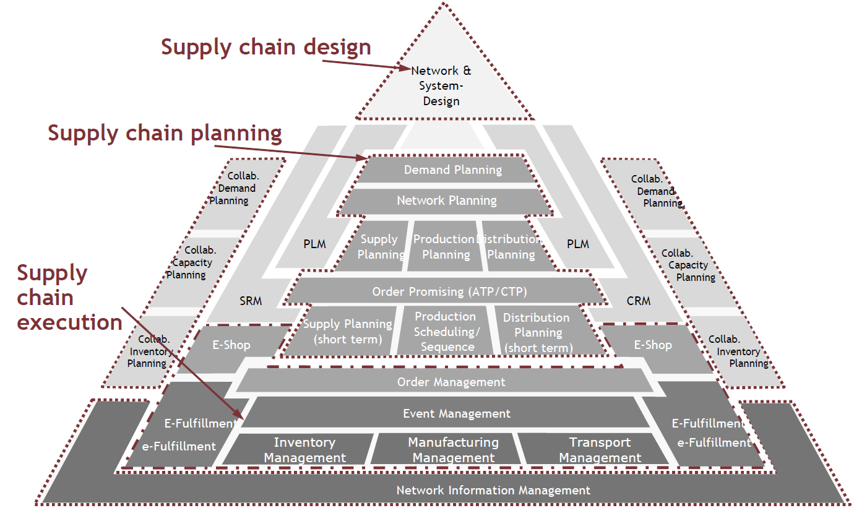

Figure 1 Hellingrath Task model for IT-systems of SCM

Design (“Supply Chain Design”)

The first layer named “Supply Chain Design” in Figure 1 contains strategic decisions regarding the overall design of the supply chain ranging from one to multiple years. Decisions made and activities facilitated in this task area focus on aligning the distribution network with the overall supply chain strategy to ensure the defined objectives are met (Kuhn and Hellingrath 2002, p. 144).

Planning (“Supply Chain Planning”)

The second layer named Supply Chain Planning (SCP) encompasses planning activities for a multitude of supply chain task areas. The generation of plans is carried out strongly hierarchical (top-down) because it is not possible to execute all planning tasks simultaneously due to high complexity of the underlying planning problem (Claus et al. 2015, p. 7) . Two different structures exist how planning can be laid out. For instance, speaking of production planning, one can empower a central planning unit, to determine *all* decision for *all* manufacturing facilities such as MRP II. This approach lacks flexibility when unexpected events occur. The other way is to perform the planning decentralized. Speaking of the same example, the production planning in this case defines a rough production plan, which has to be fine planned for each manufacturing facility (Saharidis et al. 2005, p. 5). This allows a facility to position itself between the bounds defined in the rough plan according to their operational knowledge.  
The goal of those plans is to align the supply chain execution to the strategy incorporated and applied in the supply chain design area (Kuhn and Hellingrath 2002, p. 144).

Execution (“Supply Chain Execution”)

The third layer: Supply Chain Execution encompasses all functions and tasks which are used for the execution of the operational processes. Focussing the inter-organizational monitoring and control of the supply chain. The main objective is to support decisions in the operational activities based on the current knowledge. This should increase the capability to react agile to changing environmental constraints such as demand changes (Kuhn and Hellingrath 2002, p. 152).

The realization of the aforementioned Cyber-physical-production systems (CPPS) will fundamentally change who is responsible of performing which task. To scope the overall impact by the advent of “Industrie 4.0” innovations, this thesis will focus on process planning, production planning and control. Thereby residing in the task areas of “planning” and “execution” and thereby discussing activities comprised in “Production Planning” and “Production Scheduling / Sequencing”.

## Production Planning and control

Schuh and Gierth deliver a task model for production planning and control systems. The model comprises four functional main areas, each describing a set of sub tasks which are discussed in the latter. The overall objective of this area is to ensure meeting deadlines, minimizing lead times, maintaining a balanced utilization of available production capacities and taking care of a low inventory stock level (Kuprat et al. 2015, p. 12).

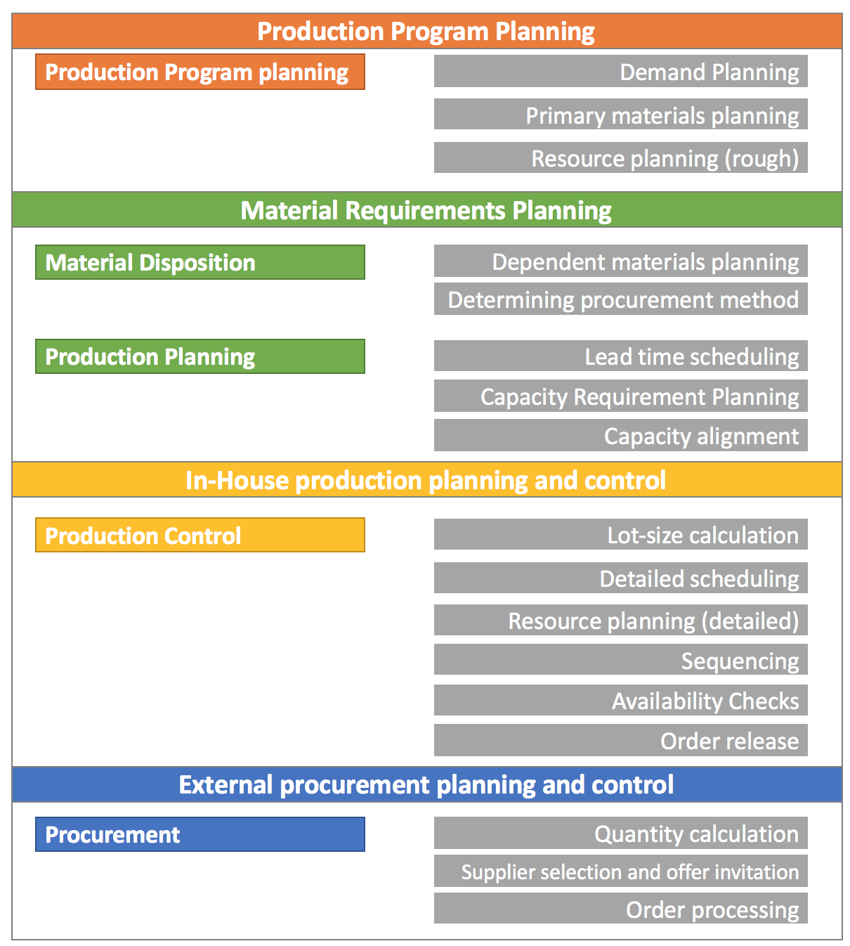

Figure 2 Task model for Production planning and control based on (Schuh and Gierth 2006)

Production Program Planning

This task area determines the goods to-be-produced in quantity, type and completion date. Result of this area is the production plan corresponding to feasibility and marketability.  
The subtask “Demand planning” defines which type of goods shall be produced in a given time period. The input necessary to define the demand plan may be the result of sales forecasting methods or stemming from sales planning to meet given profitability goals.

The following “Primary materials planning” task performs a matching of the demand plan and additional existent orders (gross primary material demand) with inventory levels per period. The result is a production programme draft featuring the total primary material demand per period.

The concluding “(gross) Resource planning” performs a check whether the demand plan and concluding draft for a production programme is applicable to real circumstances. This is made possible using a gross scheduling of demands featuring types, quantities and completion dates. (Schuh and Roesgen 2006, pp. 37–42)

Material Requirements Planning

This task area is responsible for planning the mid-term necessary resources to realize the production programme. Resources are all factors which are used in the production process, ranging from raw materials, to workforce and means of transportation. The area comprises two sub areas which are *“material disposition”* and *“production planning”*

*“Material disposition”* features the sub tasks *“Dependent materials planning”* which resolves the production programme into total dependent requirements. The concluding steps determines the procurement method for the dependent requirements and decides whether a requirement may be procured or has to be produced in-house.

Following this, the *“Lead time scheduling”* is triggered which performs a first scheduling of resolved production orders and procurement orders. Concluding this, the *“Capacity requirement planning”* determines the necessary production capacity by scheduling production orders to production resources. Ultimately performing *“Capacity alignment”* matches required capacity and available capacity per period. (Schuh and Roesgen 2006, pp. 42–49)

For task fulfilment this and the previous area engages Enterprise-Resource-Planning systems (ERP) using Production-Planning systems (PPS) or Advanced Planning and Scheduling (APS) systems (Schuh and Lassen 2006, p. 196). These allow to simultaneously plan the relevant resources, which are material, production capacity and human resources.

In-house production planning and control

The objective of this task area is to find a way of scheduling in-house orders created by material requirements planning to ensure availability of necessary production resources during all periods.

All steps of the manufacturing area are assigned to one or multiple manufacturing lots. It’s the objective of the *“Lot-size calculation”* to determine a optimal lot-size. The calculation suffers a trade-off between having a high level of unfinished products at high lot-sizes while having increasing preproduction costs at lower lot-sizes (Schuh and Roesgen 2006, p. 52).

The “*Detailed Scheduling*” calculates the start and completion date for each production lot. By minding the actual manufacturing and transition times between production steps the throughput time per order is calculated.

Whereas the previous detailed scheduling has been performed on the assumption of unlimited capacity, the *“Detailed Resource Planning”* takes care of matching necessary resources to available resources and thereby adapting the previous plan (and calculated throughput time of orders).

Given a planning period, the assigned operations forge a queue per production resource. The sequence in this queue is analysed and may be optimized within the “*Sequencing*” task area. This optimization is performed on a set of criteria e.g. by the priority of dependent orders or the type of operations in order to minimize set-up times (Schuh and Roesgen 2006, p. 54).

Prior to releasing an order to production on shop-floor, *“Availability Checks”* are performed to guarantee, that all necessary resources especially material and production capacity are available for this very order. This task area marks the advent of steering tasks of in-house production planning and control (Schuh and Roesgen 2006, p. 55).

Ultimately the *“Order Release”* is performed. Within this task the provision of resources is triggered and all connected systems are informed about this event e.g. the material management system. The release may be performed using defined rules or according to the load-oriented order release which prioritizes orders by their due dates (Schuh and Roesgen 2006, p. 56).

This task area uses an ERP system for task fulfilment. In addition, a Manufacturing Execution System (MES) can be added to the ERP if the provided functionality regarding detailed scheduling/sequencing, simulation of the production process and monitoring does not fit the requirements of the production process (Schuh and Lassen 2006, p. 197).

External procurement planning and control

The to-be-procured goods defined in “Material Requirements Planning” are realised in this task area. The *“Quantity Calculation”* bundles the requirements on to-be-procured goods in a planning period to procurement orders.

To allow cost-optimal ordering, the order quantities are optimized based on minimizing fixed procurement costs. Are the necessary requirements new in a way that a resource has not been procured before, a suitable supplier has to be selected in the *“Supplier selection and offer invitation”* task area.

Finally, the procurement order may be released and is processed in the *“Order processing”* task area. The area is concerned with monitoring procured quantities with respect to delivery dates and incoming goods. (Schuh and Roesgen 2006, p. 58).

# Impact of Industrie 4.0 innovations on PPC

## Production Program and Material Requirements Planning

## In-house Production Planning and Control

Connection to Process Planning

The term “Process and production planning” comprises planning activities realized at the interface between product development and the actual production (Lachenmaier et al. 2015, p. 2). The Product Development step creates a digital product model of a prototype including the Bill of Material (BOM) which features all required components to manufacture the product. As soon as a defined stage of development has reached Process Planning delivers a plan containing all steps necessary to realize the digital product model (Lachenmaier et al. 2015, p. 5). For creation of the process plan means of simulation are embodied to identify process steps, which are not possible on the shop floor due to physical restrictions (Bracht 2002, p. 9). The final plan includes directives to workers and steering instructions for involved machines in the production process. As soon as the process steps for humans and machines are defined they are stored in the Enterprise-Resourcing-Planning System (ERP) and made accessible to Production Planning. Production planners are now able to calculate the optimal lot-size according to available orders (in the case of contract manufacturing). Lastly orders are placed into a sequence (scheduling) within existing production capacities (Harjes and Scholz-Reiter 2013, p. 663).

Ultimately the production begins, closely controlled and monitored by production planners (Lachenmaier et al. 2015, p. 2).

|  |  |  |
| --- | --- | --- |
|  | **Process Planning** | **Production Planning** |
| **Product/Order-related tasks** | Design of process plans  Design of steering programs for machines  Simulation of the production process | Lot-sizing problem  Schedule Planning  Capacity Planning (detailed) |
| **Overall tasks** | Simulation of the entire production system | Primary Requirements Planning  Material Requirements Planning  Capacity Planning  Site Planning  Technology Planning |

Table 1 Tasks of Process and Production Planning adapted from (Lachenmaier et al. 2015)

Table 1 delivers an overview of occurring tasks in Process and Production Planning. Lachenmaier et al. expect that especially the grey-highlighted, product-order related tasks, which have been described in the paragraph above, are changing by the advent of “Industrie 4.0” innovations. This corresponds with the view shared by Kuprat et al. assuring the major importance of a (conventional) centralized planning instance responsible for overall tasks (Kuprat et al. 2015, p. 15) coordinating the new autonomous decision makers (Kuprat et al. 2015, p. 13).

## Human

# Concept of Integration

Motivation: Describe IS as composition of Humans (qualifications, competencies), Applications (functions) and Processes (flexibility)

## Application / Processes

- Infrastructure -

As Bauernhansl pointed out, three layers (more specific systems) exist where automation tasks are performed. Ranging from the Enterprise-Resource-Planning System (ERP), to the Manufacturing Execution System (MES) and concluding at the shop-floor systems which actually automate physical components according to obtained data as input. (Bauernhansl 2014)

A main requirement to embrace the advent of possible innovations through cyber-physical systems is targeting the architecture of applications deployed in companies. These tend to follow monolithic patterns where integration is defined through standardized interfaces. Those patterns do not allow to connect functionality of the application in entirely new ways. This creates a mismatch of flexibility available on the system-side and flexibility necessary to implement (and fully benefit) from decentralized planning approaches. The author recommends to follow Service-Oriented-Architectures (SOA) which can be seen as layered applications. Discrete functions are encapsulated in services. Exploiting a communication layer which abstracts from platform and communication protocol details, the functional service units can be orchestrated and thereby connected in completely new ways (Tran et al. 2012).

hence lack of integrated communication interfaces. E.g. there is no direct communication possibility between the systems on the shop-floor and the

## Humans

Focus on organizational structures and work environments.

How do the decentralized planning approaches change the way humans work together?

# Conclusion

# References

Bauernhansl, T. 2014. “Die Vierte Industrielle Revolution – Der Weg in ein wertschaffendes Produktionsparadigma,” in *Industrie 4.0 in Produktion, Automatisierung und Logistik SE - 1*T. Bauernhansl, M. ten Hompel, and B. Vogel-Heuser (eds.), Springer Fachmedien Wiesbaden, pp. 5–35 (doi: 10.1007/978-3-658-04682-8_1).

Bracht, U. 2002. “Ansätze und Methoden der Digitalen Fabrik,” *Simulation und Visualisierung* (28), pp. 1–12 (available at http://www.imab.tu-clausthal.de/fileadmin/homes/mf_imab/dateien/veroeffentlichungen/93.pdf).

Brettel, M., Friederichsen, N., Keller, M., and Rosenberg, M. 2014. “How Virtualization , Decentralization and Network Building Change the Manufacturing Landscape: An Industry 4.0 Perspective,” *International Journal of Mechanical, Aerospace, Industrial and Mechatronics Engineering* (8:1), pp. 37–44.

Claus, T., Herrmann, F., and Manitz, M. 2015. “Knappe Kapazitäten und Unsicherheit — Analytische Ansätze und Simulation in der Produktionsplanung und -steuerung,” in *Produktionsplanung und –steuerung SE - 1*T. Claus, F. Herrmann, and M. Manitz (eds.), Springer Berlin Heidelberg, pp. 3–6 (doi: 10.1007/978-3-662-43542-7_1).

Frank, U., Giese, H., Klein, F., Oberschelp, O., Schmidt, A., Schulz, B., V\"ocking, H., Witting, K., and Gausemeier, J. 2004. “Selbstoptimierende Systeme des Maschinenbaus-Definitionen und Konzepte,” *Paderborn: HNI Verlagsschriftenreihe*.

Harjes, F., and Scholz-Reiter, B. 2013. *Selbststeuernde Logistik im Umlaufmanagement von Verleihartikeln* *Simulation in der Produktion und Logistik - Entscheidungsunterstützung von der Planung bis zur Steuerung*.

Hirsch-Kreinsen, H., and Weyer, J. 2014. “Wandel von Produktionsarbeit–„Industrie 4.0 “,” *Soziologisches Arbeitspapier* (38).

Kuhn, A., and Hellingrath, B. 2002. *Supply Chain Management: Optimierte Zusammenarbeit in der Wertschöpfungskette*, Berlin, Heidelberg: Springer Berlin Heidelberg (doi: 10.1007/978-3-662-10141-4).

Kuprat, T., Mayer, J., and Nyhuis, P. 2015. “Aufgaben der Produktionsplanung im Kontext von Industrie 4.0,” *Industrie Management* (31:2), pp. 11–14.

Lachenmaier, J., Lasi, H., and Kemper, H.-G. 2015. “Entwicklung und Evaluation eines Informationsversorgungskonzepts für die Prozess- und Produktionsplanung im Kontext von Industrie 4.0,” *Internationale Tagung Wirtschaftsinformatik*, pp. 1–15.

Lüder, A. 2014. “Integration des Menschen in Szenarien der Industrie 4.0,” in *Industrie 4.0 in Produktion, Automatisierung und Logistik SE - 24*T. Bauernhansl, M. ten Hompel, and B. Vogel-Heuser (eds.), Springer Fachmedien Wiesbaden, pp. 493–507 (doi: 10.1007/978-3-658-04682-8_24).

Saharidis, G., Dallery, Y., and Karaesmen, F. 2005. “Centralized versus decentralized production planning,” pp. 1–14.

Schlick, J., Stephan, P., Loskyll, M., and Lappe, D. 2014. “Industrie 4.0 in der praktischen Anwendung,” in *Industrie 4.0 in Produktion, Automatisierung und Logistik SE - 3*T. Bauernhansl, M. ten Hompel, and B. Vogel-Heuser (eds.), Springer Fachmedien Wiesbaden, pp. 57–84 (doi: 10.1007/978-3-658-04682-8_3).

Schuh, G. 2015. “ProSENSE - Ergebnisbericht des BMBF-Verbundprojektes,” (Vol. 1), Aachen.

Schuh, G., and Gierth, A. 2006. “Grundlagen der Produktionsplanung und -steuerung,” *Produktionsplanung und -steuerung - Grundlagen, Gestaltung und Konzepte*, pp. 11–27 (doi: 10.1007/3-540-33855-1).

Schuh, G., and Lassen, S. 2006. “Funktionen,” in *Produktionsplanung und -steuerung - Grundlagen, Gestaltung und Konzepte*, pp. 195–292.

Schuh, G., and Roesgen, R. 2006. “Aufgaben,” in *Produktionsplanung und -steuerung - Grundlagen, Gestaltung und Konzepte*G. Schuh (ed.), Berlin, Heidelberg: Springer Berlin Heidelberg, pp. 28–80 (doi: 10.1007/3-540-33855-1).

Soder, J. 2014. “Use Case Production: Von CIM über Lean Production zu Industrie 4.0,” in *Industrie 4.0 in Produktion, Automatisierung und Logistik SE - 4*T. Bauernhansl, M. ten Hompel, and B. Vogel-Heuser (eds.), Springer Fachmedien Wiesbaden, pp. 85–102 (doi: 10.1007/978-3-658-04682-8_4).

Tran, H., Zdun, U., Holmes, T., Oberortner, E., Mulo, E., and Dustdar, S. 2012. “Compliance in service-oriented architectures: A model-driven and view-based approach,” *Information and Software Technology* (54:6), Elsevier B.V., pp. 531–552 (doi: 10.1016/j.infsof.2012.01.001).

Weyrich, M., Diedrich, C., Fay, A., Wollschlaeger, M., Kowalewski, S., Göhner, P., and Vogel-Heuser, B. 2014. “Industrie 4.0 am Beispiel einer Verbundanlage,” *atp edition - Automatisierungstechnische Praxis* (56:07-08), p. 52 (doi: 10.17560/atp.v56i07-08.301).

Declaration of Authorship

I hereby declare that, to the best of my knowledge and belief, this Seminar Thesis is my own work. I confirm that each significant contribution to and quotation in this thesis that originates from the work or works of others is indicated by proper use of citation and references.

Münster, 26 February 2016

